

**PAT-A-DOC**

Healthcare Support System

TABLE OF CONTENTS:

* Team and constraint Details
* Abstract
* Modules
* Project Purpose

1. Outlook of pat-a-doc
2. Registration

* Creating appointment
* Types of Diseases
* Types of Doctors
* After Filling Appointment details
* After Consulting
* Schema and ER diagram
* Sample pages

1. Team Details and Constraints:

|  |  |  |  |
| --- | --- | --- | --- |
| SAP ID | Name | Role | Email id |
| 51792244 | Baby Sathya | Business Logic | babysathyabala@gmail.com |
| 51790023 | Bhaskar | Presentation | bbhaskar602@gmail.com |
| 51789888 | Gavya sree | Database | sreegavya@gmail.com |
| 51789904 | Saranya | Connectivity | saranyavedhachalam@gmail.com |
| 51790249 | Selvacyril | Documentation | selvacyril7@gmail.com |
| 51789934 | Anand | Model class | anandharinn@gmail.com |

|  |  |
| --- | --- |
| Hardware Constraints | |
| System Type | 32 bit or 64 bit |
| RAM | 2 GB |
| Software Constraints | |
| Operating System | Windows 8 and higher |
| Programming Language | J2EE |
| Architecture | MVC |
| Environment | JRE 8 |
| Server | Apache Tomcat 8.0 |
| Database | Oracle 11g |
| Platform | JDK 1.8 |
| Testing | Junit |
| IDE | Eclipse Luna version 4.4.1 |
| External jars | Odbc-14.jar,servlet-api.jar, activation.jar,mail.jar |

1. Abstract:

Our project focuses on the patient needs. Nowadays people are facing huge difficulties in consulting a doctor. One of the main problems is wasting time by waiting in a dull and monotonous waiting hall with the long queuesfor consulting the doctor. Sometimes getting appointment also becomes a struggling task. Because people may have to undergo the process of contacting the hospital or the doctor physically or through a call to book the appointment.

In order to make it easy for the people, our PAT-A-DOC healthcare system is going to make the process much easier for the users. PAT-A-DOC healthcare system bridges the gap between the patient and the doctor and makes it more beneficial for both patient as well as the doctor. Through this initiative, doctors will also get enough number of patients, there by benefitting the doctor as well.

In fact, [according to a stat](http://kaysharbor.com/blog/healthcare/40-amazing-mhealth-statistics-to-blow-your-mind), 93% of the doctors believe that healthcare system can bring improvement in patient’s health and 80% of the physicians are using the mobile technology to deliver the patient care.

In todays tech world, even the prescription of the doctors have become digitalized, which means it can be accessed on your device. It helps them (medical professionals) to view all your reports through the app makes it easier to take quick and apt decisions in emergency cases. The information can be exchange within a wink of an eye.

One of the major advantages of the healthcare apps have been the reduction of medical bills and expanses. Skyrocketing bills and large medicinal expanses have always been the headache for people because the hospitals charge fee at their will.

However, since some of the tasks can be done through app, it will help in easing the burden off your pocket. Moreover, you can also choose the hospital according to your budget.

Project view: We used the top available technologies like JAVA for general coding, JSP &CSS & HTML for user interface, Oracle for database , JDBC for database connectivity, JS for validations and Servlets. Both the doctor and the patient have to undergo one-time registration process. The registered details of all the patients and doctors will be stored in our database separately. The user will get an temporary password for logging in for the first time and are asked to change the password of their own for security reasons as well as user preferred password. This is applicable for both the doctor as well as the patient.

The patients have to select the type of illness that suffer, that also comes with an option of “could not be diagnosed” and have to select the doctor as per their wish and then selecting the day and time of appointment from the list of available slots of the doctor. The patient can select the date and time of the appointment only within the ten days from the current date. After filling the form, our system will generate the unique appointment id which will also be displayed in the doctor’s dashboard as well as patient’s dashboard. After the appointment time has been finished, the doctor has the freedom to set the status of the appointment to “completed” and also will update the prescription which can purchased by the patient after paying it through the patient login.

1. Modules:
2. Selecting the Domain for Patient or Doctor.
3. Registration of Patient and Doctor.
4. Selecting the Vertical of the type of CARE(Emergency or Inpatient or Outpatient).
5. Filling the form for fixing the Appointment.
6. Dashboard showing the status of appointment
7. Payment for viewing Prescription(patient) and Page for updating the prescription by doctor.
8. Project Purpose:

This presentation illustrates the functional specifications of the Pat-a-Doc Healthcare support services.

The following are the important modules of the project:

**For Patient:-**

1. Registration.
2. Patient ID and password will be generated.
3. The generator password is temporary and need to change the password for security reasons.
4. Patient will change their password and set the new password.
5. Login page.
6. Selection of type of illness the patient wants to consult.
7. Patients are provided with comment box to address their issue in detail.
8. Appropriate Doctors can be selected based on the selection of disease.
9. In that, The Doctors Experience and their dates are displayed.
10. The patient have to choose the flexible date for them.
11. The appointment is booked with reference id generated to patient and Doctor.

**For Doctor:-**

1. Registration.
2. Doctor ID and password will be generated.
3. The generator password is temporary and need to change the password for security reasons.
4. Doctor will change their password and set the new password.
5. Login page.
6. Doctor can see the patient info and appointment in the page.
7. Doctor can set the status of appointment and write prescription.
   1. Outlook of Pat-a-doc:

Steps and Actions:

1. Patient need to register the details for the Pat-a-Doc access.

2. Patient will be able to enter details of the disease.

3. System should display all the necessary fields for the Patient.

4. Subsequent appointment is created for Patient with regard to illness filed.

Business Rules & Validations

1. Patient cannot give false information and wrong claims.
2. All the mandatory fields should be entered.
   1. Registration:

User(patient and doctor) should submit the prerequisite details for registration and login there by.

Pre-Conditions/Assumptions:

Patient and Doctor database has to be maintained.

Post-Conditions:

Registered Patient and Doctor details has to be maintained in database for future purpose.

Steps & Actions:

1. Login is must.
2. Patient and Doctor can submit the details and access login.

Business Rules & Validations

1. Appropriate name and password has to be matched with customer database.
2. All the fields are mandatory.
3. Creating the Appointment:

*After completing successful login in Pat-a-Doc application, the page gets navigated to the main page.

Pre-conditions/Assumptions:

In the main page three verticals are displayed, Emergency, Inpatient and Outpatient. For Outpatient, Patient need to select the type of illnessand the specialized doctors in that field is displayed as per their wish. For Inpatients, they need to select the hospital name, illness number of days and previous prescription.

Post-conditions:

After submission of details, the details are passed to the doctor’s table to check the availability of the doctor’s date and time.

Success End Condition:

The appointment details are send to the next servlet for checking the availability and then to the payment page.

Failure End Condition:

In case of no availability patient is requested to select different time and date, displaying this message in alert box.

Steps & Action:

1. Web page will display all the necessary fields in the screen.
2. Appointment details are forwarded to the payment page.
3. Date and time details are compared with the doctor’s table to check the availability.

Business Rules and Logic

1. Details must be entered correctly.
2. Details about the illness are needed to be given accordingly.
3. These details can help the Doctor to prepare for the appointment.
4. Types of disease:

The required fields of disease columns to be filled correctly.

*Heart disease

*Cancer

*Respiratory

*Neurology

*Diabetes

## *Kidney disease

*Asthma & Allergies

*Liver disease

*Skin & Hair

*Oral health

*Bone health

*Digestion

*Child care

*Weight Loss Management

*Women care

*Eye care

*Others

1. Types of Doctors:

The required fields should be filled correctly.

*Cardiologist

* Dermatologist

* Gynecologist

* Oncologist

*Gastroenterologist

*Nephrologist

*Neurologist

*Ophthalmologist

*Orthopedist

*Otolaryngologist

*Psychiatrist

*pulmonologist

*Urologist

*physiotherapist

1. After Filling appointment:

After filling the appointment form, the page will be forwarded to the payment page after validating the appointment date and time.

Pre-conditions/Assumptions:

The availability date and time of the doctor has to be checked.

Post-conditions:

The patients are asked to make the payment for the appointment to book, by asking the credit card number and cvv.

Success End Condition:

Appointment is booked and the details are stored in the table of both doctor as well as the patient in the database.

Failure End Condition:

In case of any violation in the business rules of the fields, patient is requested to fill the form again.

Steps & Action:

* + - 1. Web page will display all the necessary payment page in the screen for patient.
      2. System will store the details into the database.

Business Rules and Logic

* + - 1. Patient should pay first to see the prescription.

1. After Consulting:

*After completing the consulting, the doctor needs to update the prescription.

Pre-conditions/Assumptions:

In the doctor login, we have a separate page for the doctor to see his/her appointment details and in that page there will be separate page for the doctor to write the prescription.

In patient login, the patient gets the prescription details after the doctor updated the prescription details.

Post-conditions:

After submission of prescription, it gets updated in the database in the database.

Success End Condition:

The details of prescription will be displayed in the patient’s dashboard and then the patient can view the prescription.

Failure End Condition:

In case of any violation in the business rules of the fields, Patient won’t get the prescription and the doctor has to look into it.

Steps & Action:

* + - 1. System will store the details into the database.

Business Rules and Logic

* + - 1. Doctor should then enter the prescription.
      2. Doctor can enter the prescription only on the appointment date or the day/days after the appointment date.

1. Schema: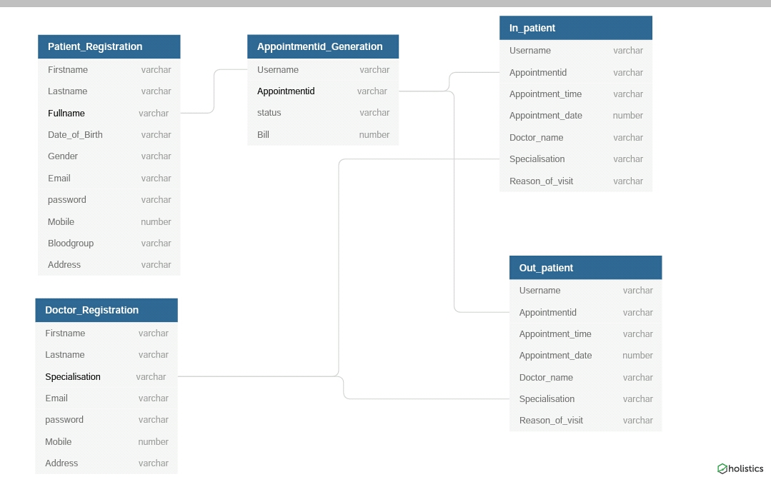
2. ER diagram

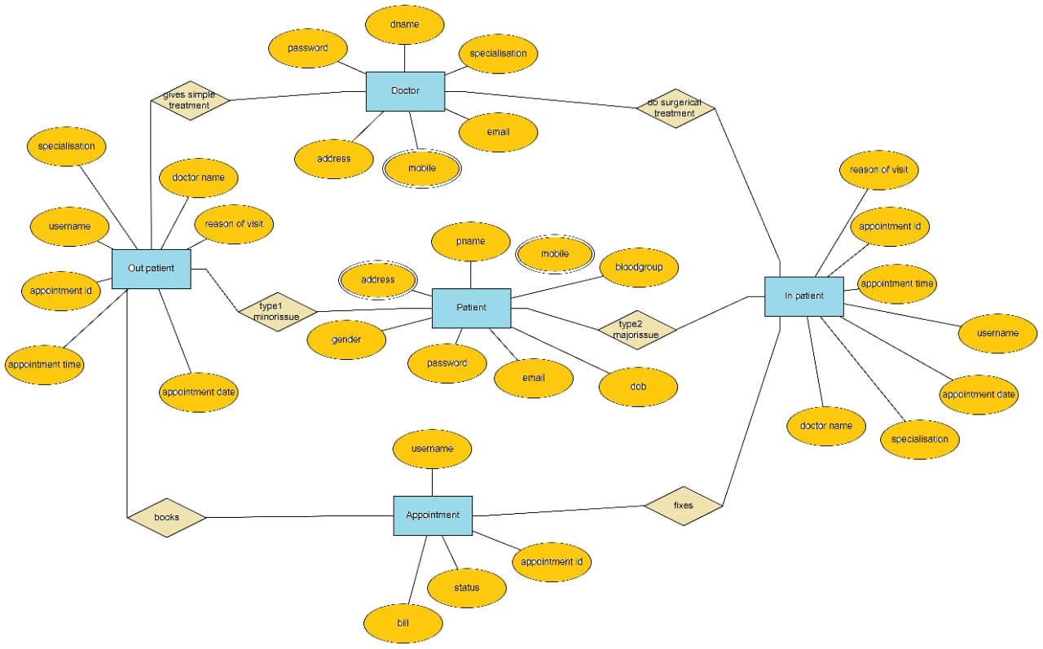

1. **Data Flow Diagram**

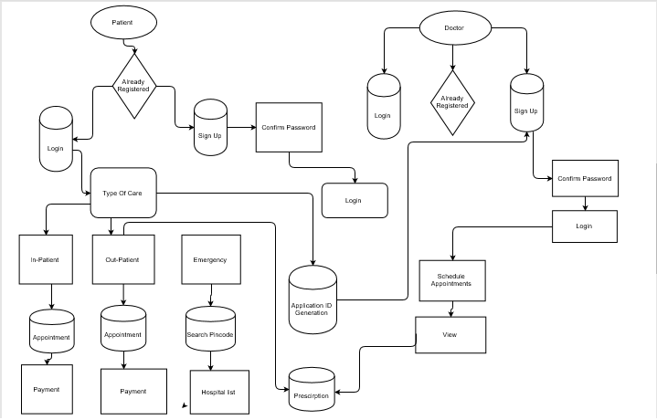

1. Sample pages:

Selecting domain patient or doctor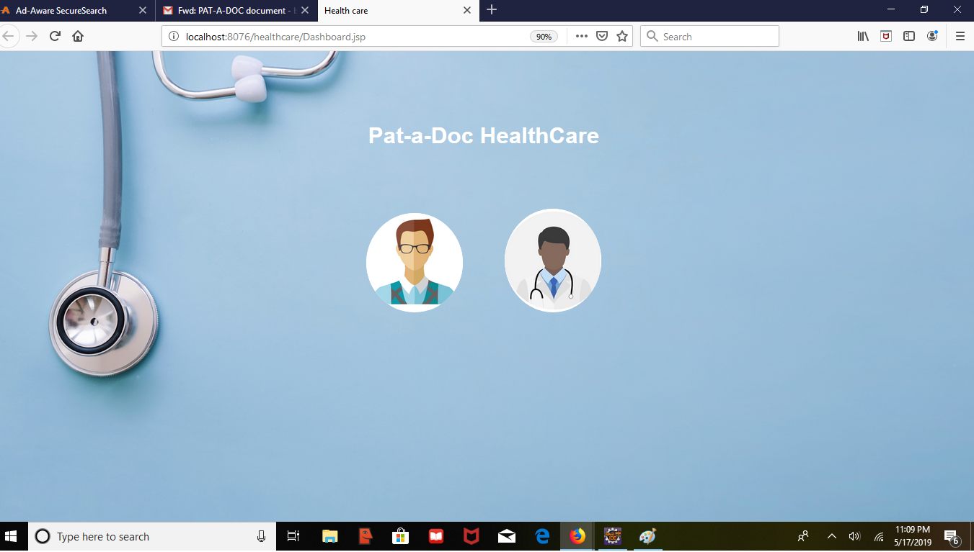

**Patient registration:**

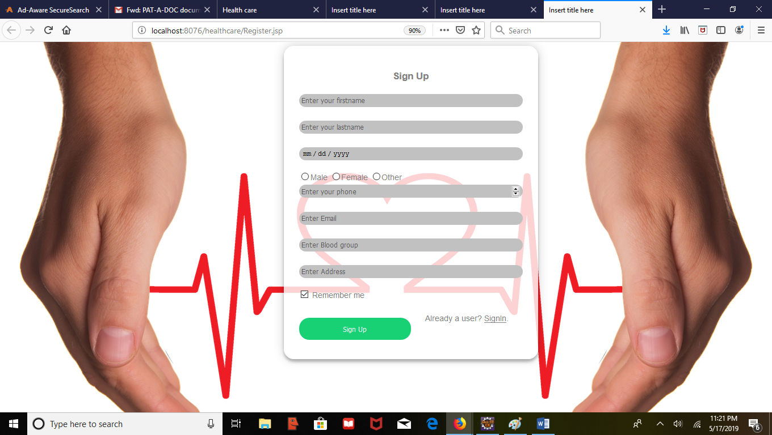

**Patient login:**

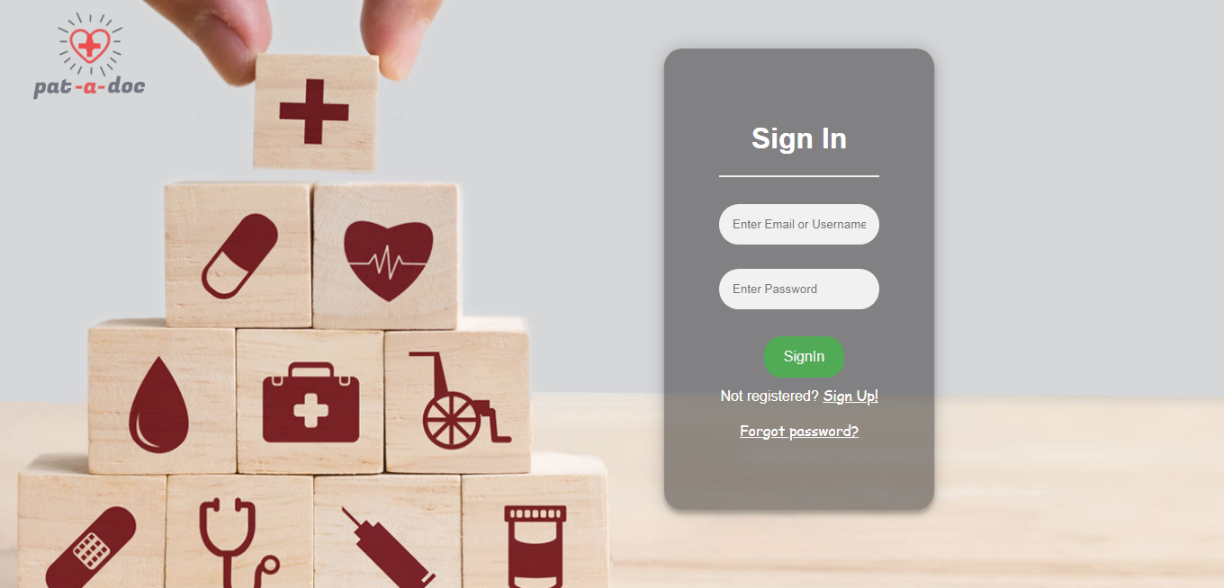

**Change in password:**

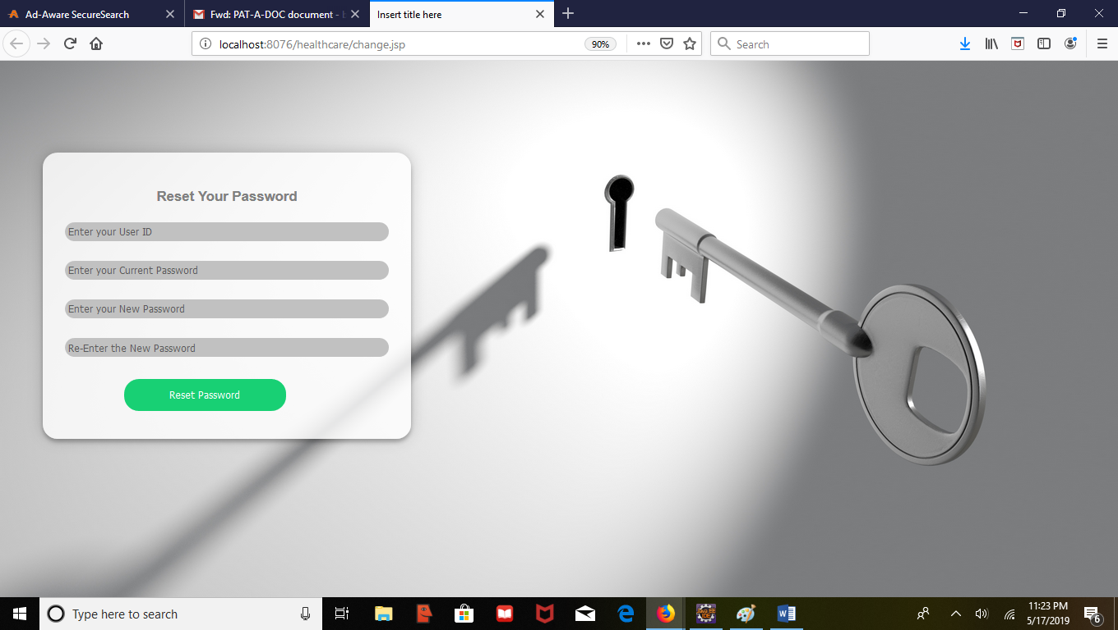

**Homepage and Care Selection:**

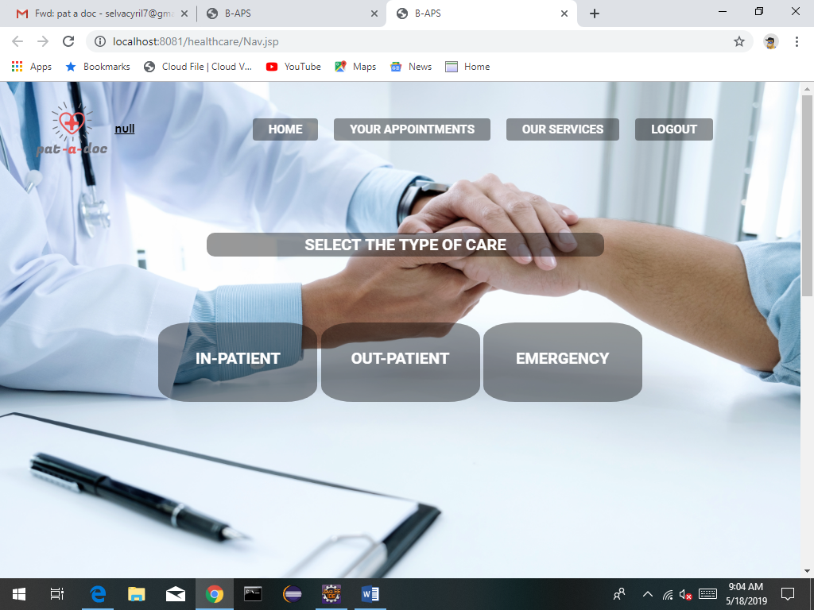

**In-patient Appointment form:**

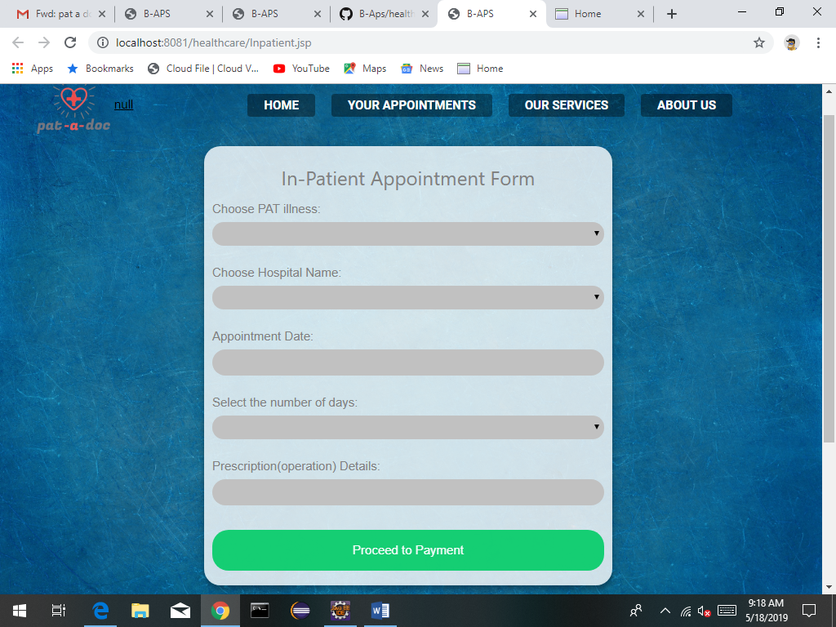

**In-Patient Payment Form:**

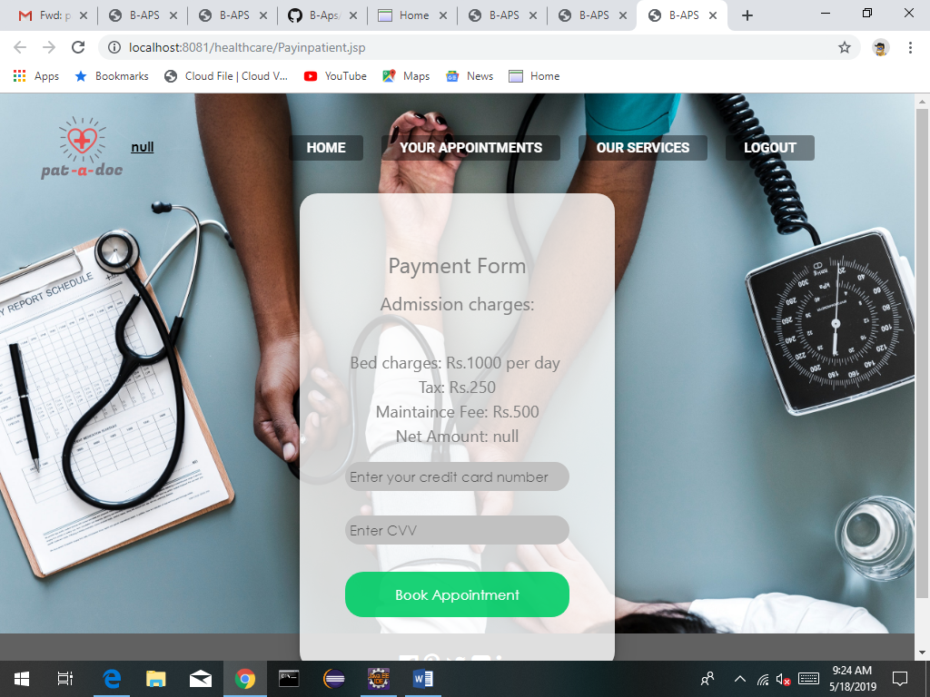

**Out-patient Appointment form:**

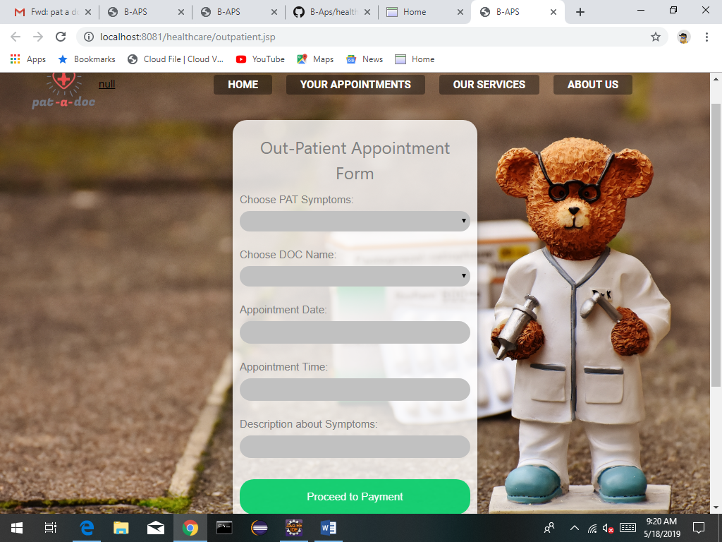

**Out-Patient Payment Form:**

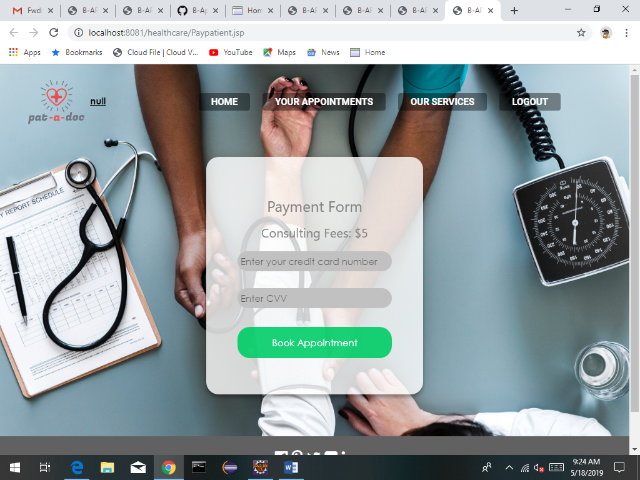

**Emergency:**

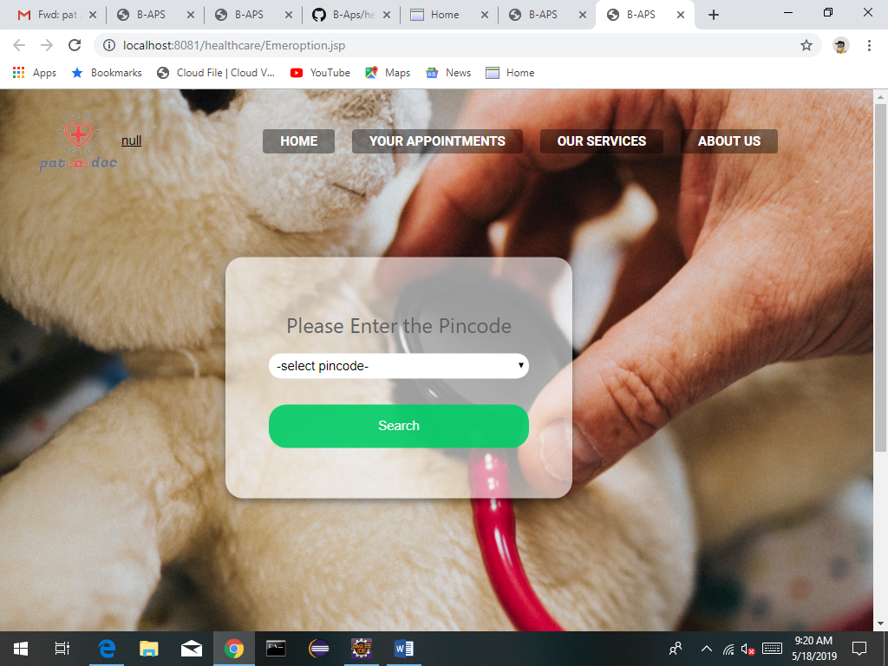

Doctor registration:

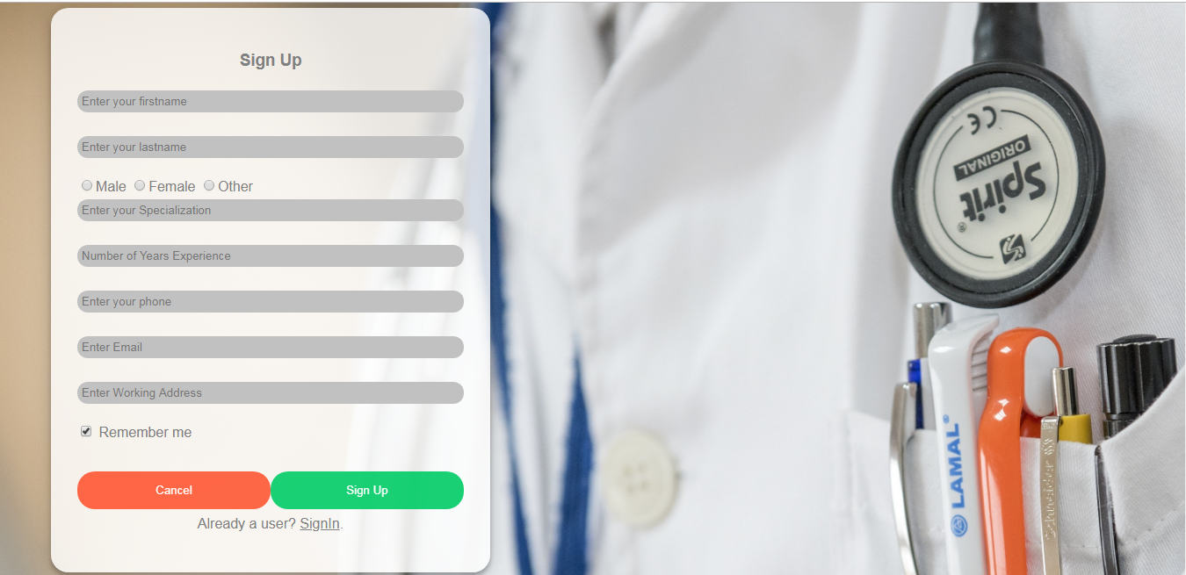

**Doctor login:**

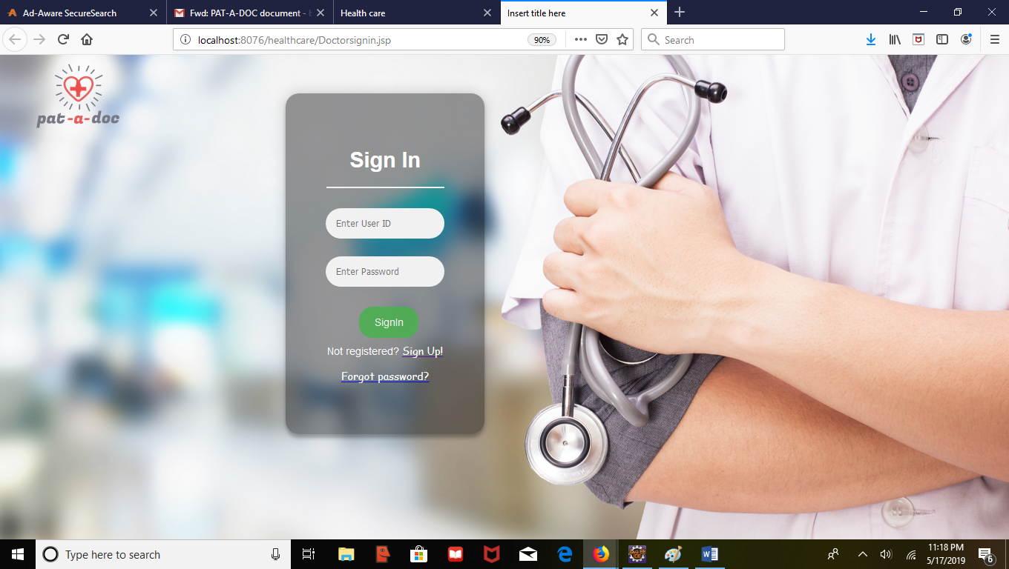

**Change in password:**

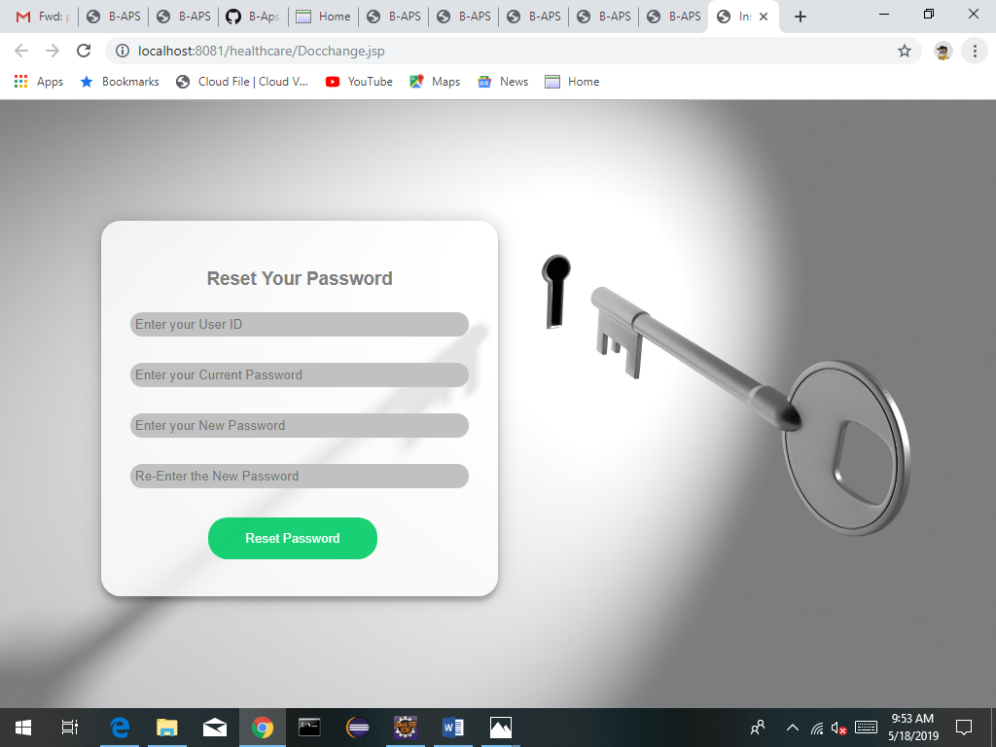

**View Appointment:**

